**The commond so far to runing the project:**

1. **If you are training in cluster:**

* **Retrain our cellyolo for cell segmentation.**

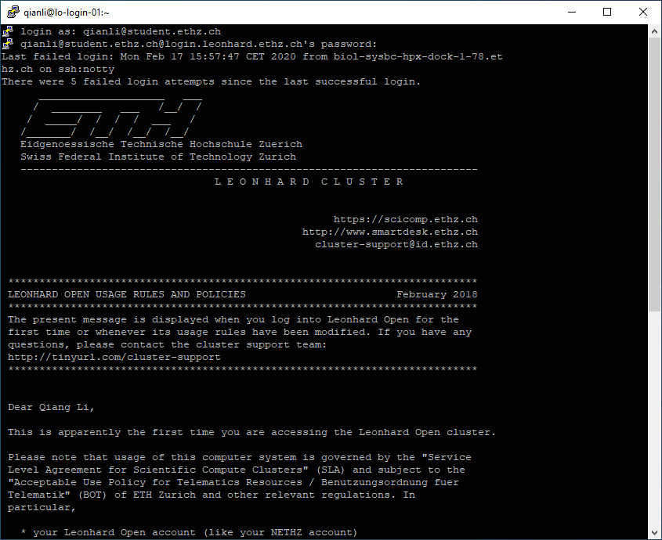

To list all available module

**module avail**

then load all necessary module, using python_gpu version there are python_cpu version as well, if you run python3 train.py then better using gpu version, all you can also check which version using

**module load python_gpu**

**module load opencv**

**module load cuda**

**module load cudnn**

there are a lot of python package available in anaconda,so we load anaconda3 as well,

as you might meet the mistake, in cluster the anaconda is not available, so you need to manually go to anaconda website to download the bish file and place that under the project folder as well

using module spider anaconda to check wether it has or not **: module spider anaconda**

and install anaconda by manually: first cd into the folder where we put the project:

**cd /nfs/nas22.ethz.ch/fs2202/biol_imsb_claassen_1/qiangli**

using dir or ls command to see the folders and install the anaconda3 manually, firstly remember to download the Anaconda3-2019.10-Linux-x86_64.sh then using the command:

**bash Anaconda3-2019.10-Linux-x86_64.sh**

check the python version using:

**python3 –version**

or:

**which python**

then set up the environment for our project, and install all the requirements package, for some of the package u should using the –user

**pip install -r requirements.txt**

**pip install opencv-python –user**

**pip install torch>=1.3 –user**

**pip install matplotlib**

**pip install tqdm**

**pip install Pillow==6.1 —user**

to submit the job using:

**bsub -n 10 -w 24:00 -R"rusage[mem=4500,ngpus_excl_p=4]" python3 train.py -i --epochs 5000**

namely we used 10 cpu cores and w stands for 24 hours, r stands for which gpuand how much gpu u using

or u can submit job like that: state clearly which gpu.

**bsub -n 20 -R "rusage[mem=4500,ngpus_excl_p=8]" -R "select[gpu_model0==GeForceGTX1080Ti]" python3 train.py --epochs 5000**

using **bbjobs** to see you job and using **bkill jobid** to kill you current job using **bpeek** to see the output information

currently. By the way all the information are saved in lsf log file

bsub -n 20 -W 8:00 -R "rusage[mem=5000,ngpus_excl_p=4]" python3 train.py --epochs 5000 --data data/coco.data --cfg cfg/yolov3-spp.cfg --batch-size 16 --accum 4 --weights weights/yolov3-spp.pt --resume

1. **If you are training in local PC:**

First Make sure you installed **cudnn, cuda and pytorch**, according to your GPU version first, and the **entire python** package.

Once you load this project, it will show what you did not install in your pycharm. Just install it in a quick way:

|  |  |  |
| --- | --- | --- |
| _anaconda_depends | 2019.03 | 2020.02 |
| _ipyw_jlab_nb_ext_conf | 0.1.0 | 0.1.0 |
| absl-py | 0.8.1 | 0.9.0 |
| alabaster | 0.7.12 | 0.7.12 |
| anaconda | custom | 2020.02 |
| anaconda-client | 1.7.2 | 1.7.2 |
| anaconda-navigator | 1.9.7 | 1.9.12 |
| anaconda-project | 0.8.3 | 0.8.4 |
| asn1crypto | 1.0.1 | 1.3.0 |
| astor | 0.8.0 | 0.8.0 |
| astroid | 2.3.1 | 2.4.1 |
| astropy | 3.2.1 | 4.0.1.post1 |
| atomicwrites | 1.3.0 | 1.4.0 |
| attrs | 19.2.0 | 19.3.0 |
| babel | 2.7.0 | 2.8.0 |
| backcall | 0.1.0 | 0.1.0 |
| backports | 1.0 | 1.0 |
| backports.functools_lru_cache | 1.5 | 1.6.1 |
| backports.os | 0.1.1 | 0.1.1 |
| backports.shutil_get_terminal_size | 1.0.0 | 1.0.0 |
| backports.tempfile | 1.0 | 1.0 |
| backports.weakref | 1.0.post1 | 1.0.post1 |
| beautifulsoup4 | 4.8.0 | 4.9.1 |
| bitarray | 1.0.1 | 1.2.1 |
| bkcharts | 0.2 | 0.2 |
| blas | 1.0 | 1.0 |
| bleach | 3.1.0 | 3.1.4 |
| blosc | 1.16.3 | 1.16.3 |
| bokeh | 1.3.4 | 2.0.2 |
| boto | 2.49.0 | 2.49.0 |
| bottleneck | 1.2.1 | 1.3.2 |
| bzip2 | 1.0.8 | 1.0.8 |
| ca-certificates | 2020.1.1 | 2020.1.1 |
| cachetools | 3.1.1 | 3.1.1 |
| certifi | 2019.11.28 | 2020.4.5.1 |
| cffi | 1.12.3 | 1.14.0 |
| chardet | 3.0.4 | 3.0.4 |
| cifar2png | 0.0.4 |  |
| click | 7.0 | 7.1.2 |
| cloudpickle | 1.2.2 | 1.4.1 |
| clyent | 1.2.2 | 1.2.2 |
| colorama | 0.4.1 | 0.4.3 |
| comtypes | 1.1.7 | 1.1.7 |
| conda | 4.8.2 | 4.8.3 |
| conda-build | 3.18.9 | 3.18.11 |
| conda-env | 2.6.0 | 2.6.0 |
| conda-package-handling | 1.6.0 | 1.6.1 |
| conda-verify | 3.4.2 | 3.4.2 |
| console_shortcut | 0.1.1 | 0.1.1 |
| contextlib2 | 0.6.0 | 0.6.0.post1 |
| cryptography | 2.7 | 2.9.2 |
| cuda92 | 1.0 |  |
| cudatoolkit | 10.1.243 | 10.2.89 |
| cudnn | 7.6.4 | 7.6.5 |
| curl | 7.65.3 | 7.69.1 |
| cycler | 0.10.0 | 0.10.0 |
| cython | 0.29.13 | 0.29.17 |
| cytoolz | 0.10.0 | 0.10.1 |
| dask | 2.5.2 | 2.17.2 |
| dask-core | 2.5.2 | 2.17.2 |
| decorator | 4.4.0 | 4.4.2 |
| defusedxml | 0.6.0 | 0.6.0 |
| distributed | 2.5.2 | 2.17.0 |
| docutils | 0.15.2 | 0.16 |
| entrypoints | 0.3 | 0.3 |
| et_xmlfile | 1.0.1 | 1.0.1 |
| fastcache | 1.1.0 | 1.1.0 |
| filelock | 3.0.12 | 3.0.12 |
| flask | 1.1.1 | 1.1.2 |
| freetype | 2.9.1 | 2.9.1 |
| fsspec | 0.5.2 | 0.7.4 |
| future | 0.18.2 | 0.18.2 |
| gast | 0.2.2 | 0.3.3 |
| get_terminal_size | 1.0.0 | 1.0.0 |
| gevent | 1.4.0 | 1.4.0 |
| git | 2.23.0 | 2.23.0 |
| glob2 | 0.7 | 0.7 |
| google-auth | 1.4.2 | 1.14.1 |
| google-auth-oauthlib | 0.4.1 | 0.4.1 |
| google-pasta | 0.1.8 | 0.2.0 |
| greenlet | 0.4.15 | 0.4.15 |
| grpcio | 1.25.0 | 1.27.2 |
| h5py | 2.8.0 | 2.10.0 |
| haishoku | 1.1.8 |  |
| hdf5 | 1.8.18 | 1.10.4 |
| heapdict | 1.0.1 | 1.0.1 |
| html5lib | 1.0.1 | 1.0.1 |
| icc_rt | 2019.0.0 | 2019.0.0 |
| icu | 58.2 | 58.2 |
| idna | 2.8 | 2.9 |
| imageio | 2.6.0 | 2.8.0 |
| imagesize | 1.1.0 | 1.2.0 |
| importlib_metadata | 0.23 | 1.6.0 |
| intel-openmp | 2019.4 | 2020.1 |
| ipykernel | 5.1.2 | 5.1.4 |
| ipython | 7.11.1 | 7.13.0 |
| ipython_genutils | 0.2.0 | 0.2.0 |
| ipywidgets | 7.5.1 | 7.5.1 |
| isort | 4.3.21 | 4.3.21 |
| itsdangerous | 1.1.0 | 1.1.0 |
| jdcal | 1.4.1 | 1.4.1 |
| jedi | 0.15.1 | 0.17.0 |
| jinja2 | 2.10.3 | 2.11.2 |
| joblib | 0.13.2 | 0.15.1 |
| jpeg | 9b | 9b |
| json5 | 0.8.5 | 0.9.4 |
| jsonpatch | 1.25 | 1.24 |
| jsonpointer | 2.0 | 2.0 |
| jsonschema | 3.0.2 | 3.2.0 |
| jupyter | 1.0.0 | 1.0.0 |
| jupyter_client | 5.3.3 | 6.1.3 |
| jupyter_console | 6.0.0 | 6.1.0 |
| jupyter_core | 4.5.0 | 4.6.3 |
| jupyterlab | 1.1.4 | 1.2.6 |
| jupyterlab_server | 1.0.6 | 1.1.4 |
| keras-applications | 1.0.8 | 1.0.8 |
| keras-preprocessing | 1.1.0 | 1.1.0 |
| keyring | 18.0.0 | 21.1.1 |
| kiwisolver | 1.1.0 | 1.2.0 |
| krb5 | 1.16.1 | 1.17.1 |
| lazy-object-proxy | 1.4.2 | 1.4.3 |
| libarchive | 3.3.3 | 3.4.2 |
| libcurl | 7.65.3 | 7.69.1 |
| libiconv | 1.15 | 1.15 |
| liblief | 0.9.0 | 0.10.1 |
| libopencv | 3.4.1 | 4.0.1 |
| libpng | 1.6.37 | 1.6.37 |
| libsodium | 1.0.16 | 1.0.18 |
| libssh2 | 1.8.2 | 1.9.0 |
| libtiff | 4.0.10 | 4.1.0 |
| libxml2 | 2.9.9 | 2.9.9 |
| libxslt | 1.1.33 | 1.1.33 |
| llvmlite | 0.29.0 | 0.32.1 |
| locket | 0.2.0 | 0.2.0 |
| lxml | 4.4.1 | 4.5.0 |
| lz4-c | 1.8.1.2 | 1.9.2 |
| lzo | 2.10 | 2.10 |
| m2w64-gcc-libgfortran | 5.3.0 | 5.3.0 |
| m2w64-gcc-libs | 5.3.0 | 5.3.0 |
| m2w64-gcc-libs-core | 5.3.0 | 5.3.0 |
| m2w64-gmp | 6.1.0 | 6.1.0 |
| m2w64-libwinpthread-git | 5.0.0.4634.697f757 | 5.0.0.4634.697f757 |
| markdown | 3.1.1 | 3.1.1 |
| markupsafe | 1.1.1 | 1.1.1 |
| matplotlib | 3.0.3 | 3.1.3 |
| mccabe | 0.6.1 | 0.6.1 |
| menuinst | 1.4.16 | 1.4.16 |
| mistune | 0.8.4 | 0.8.4 |
| mkl | 2019.4 | 2020.1 |
| mkl-service | 2.3.0 | 2.3.0 |
| mkl_fft | 1.0.14 | 1.0.15 |
| mkl_random | 1.1.0 | 1.1.1 |
| mock | 3.0.5 | 4.0.2 |
| more-itertools | 7.2.0 | 8.3.0 |
| mpmath | 1.1.0 | 1.1.0 |
| msgpack-python | 0.6.1 | 1.0.0 |
| msys2-conda-epoch | 20160418 | 20160418 |
| multipledispatch | 0.6.0 | 0.6.0 |
| navigator-updater | 0.2.1 | 0.2.1 |
| nbconvert | 5.6.0 | 5.6.1 |
| nbformat | 4.4.0 | 5.0.6 |
| networkx | 2.3 | 2.4 |
| ninja | 1.9.0 | 1.9.0 |
| nltk | 3.4.5 | 3.4.5 |
| nose | 1.3.7 | 1.3.7 |
| notebook | 6.0.1 | 6.0.3 |
| numba | 0.45.1 | 0.49.1 |
| numexpr | 2.7.0 | 2.7.1 |
| numpy | 1.16.2 | 1.18.1 |
| numpy-base | 1.16.5 | 1.18.1 |
| numpydoc | 0.9.1 | 0.9.2 |
| oauthlib | 3.1.0 | 3.1.0 |
| olefile | 0.46 | 0.46 |
| opencv | 3.4.1 | 4.0.1 |
| opencv-python | 4.2.0.32 |  |
| openpyxl | 3.0.0 | 3.0.3 |
| openssl | 1.1.1d | 1.1.1g |
| opt-einsum | 3.1.0 |  |
| packaging | 19.2 | 20.3 |
| pandas | 0.25.1 | 1.0.3 |
| pandoc | 2.2.3.2 | 2.2.3.2 |
| pandocfilters | 1.4.2 | 1.4.2 |
| parso | 0.5.1 | 0.7.0 |
| partd | 1.0.0 | 1.1.0 |
| path.py | 12.0.1 | 12.4.0 |
| pathlib | 1.0.1 | 1.0.1 |
| pathlib2 | 2.3.5 | 2.3.5 |
| patsy | 0.5.1 | 0.5.1 |
| pep8 | 1.7.1 | 1.7.1 |
| pickleshare | 0.7.5 | 0.7.5 |
| pillow | 6.1.0 | 7.1.2 |
| pip | 19.3.1 | 20.0.2 |
| pkginfo | 1.5.0.1 | 1.5.0.1 |
| pluggy | 0.13.0 | 0.13.1 |
| ply | 3.11 | 3.11 |
| powershell_shortcut | 0.0.1 | 0.0.1 |
| prometheus_client | 0.7.1 | 0.7.1 |
| prompt_toolkit | 2.0.10 | 3.0.5 |
| protobuf | 3.11.1 | 3.11.4 |
| psutil | 5.6.3 | 5.7.0 |
| ptflops | 0.5.2 |  |
| py | 1.8.0 | 1.8.1 |
| py-lief | 0.9.0 | 0.10.1 |
| py-opencv | 3.4.1 | 4.0.1 |
| pyasn1 | 0.4.8 | 0.4.8 |
| pyasn1-modules | 0.2.7 | 0.2.7 |
| pycocotools | 2.0 |  |
| pycodestyle | 2.5.0 | 2.6.0 |
| pycosat | 0.6.3 | 0.6.3 |
| pycparser | 2.19 | 2.20 |
| pycrypto | 2.6.1 | 2.6.1 |
| pycurl | 7.43.0.3 | 7.43.0.5 |
| pyflakes | 2.1.1 | 2.2.0 |
| pygments | 2.4.2 | 2.6.1 |
| pylint | 2.4.2 | 2.5.2 |
| pyodbc | 4.0.27 | 4.0.30 |
| pyopenssl | 19.0.0 | 19.1.0 |
| pyparsing | 2.4.2 | 2.4.7 |
| pyqt | 5.9.2 | 5.9.2 |
| pyreadline | 2.1 | 2.1 |
| pyrsistent | 0.15.4 | 0.16.0 |
| pysocks | 1.7.1 | 1.7.1 |
| pytables | 3.4.4 | 3.6.1 |
| pytest | 5.2.1 | 5.4.2 |
| pytest-arraydiff | 0.3 | 0.3 |
| pytest-astropy | 0.5.0 | 0.8.0 |
| pytest-doctestplus | 0.4.0 | 0.5.0 |
| pytest-openfiles | 0.4.0 | 0.5.0 |
| pytest-remotedata | 0.3.2 | 0.3.2 |
| python | 3.7.4 | 3.8.3 |
| python-dateutil | 2.8.0 | 2.8.1 |
| python-libarchive-c | 2.8 | 2.9 |
| pytorch-cpu | 1.1.0 |  |
| pytz | 2019.3 | 2020.1 |
| pywavelets | 1.0.3 | 1.1.1 |
| pywin32 | 223 | 227 |
| pywinpty | 0.5.5 | 0.5.7 |
| pyyaml | 5.1.2 | 5.3.1 |
| pyzmq | 18.1.0 | 18.1.1 |
| qt | 5.9.7 | 5.9.7 |
| qtawesome | 0.6.0 | 0.7.0 |
| qtconsole | 4.5.5 | 4.7.4 |
| qtpy | 1.9.0 | 1.9.0 |
| requests | 2.21.0 | 2.23.0 |
| requests-oauthlib | 1.3.0 | 1.3.0 |
| rope | 0.14.0 | 0.17.0 |
| rsa | 4.0 | 4.0 |
| ruamel_yaml | 0.15.46 | 0.15.87 |
| scikit-image | 0.15.0 | 0.16.2 |
| scikit-learn | 0.21.3 | 0.22.1 |
| scipy | 1.3.1 | 1.4.1 |
| seaborn | 0.9.0 | 0.10.1 |
| send2trash | 1.5.0 | 1.5.0 |
| setuptools | 41.4.0 | 47.1.1 |
| simplegeneric | 0.8.1 | 0.8.1 |
| singledispatch | 3.4.0.3 | 3.4.0.3 |
| sip | 4.19.8 | 4.19.13 |
| six | 1.12.0 | 1.15.0 |
| snappy | 1.1.7 | 1.1.7 |
| snowballstemmer | 2.0.0 | 2.0.0 |
| sortedcollections | 1.1.2 | 1.1.2 |
| sortedcontainers | 2.1.0 | 2.1.0 |
| soupsieve | 1.9.3 | 2.0.1 |
| sphinx | 2.2.0 | 3.0.4 |
| sphinxcontrib | 1.0 | 1.0 |
| sphinxcontrib-applehelp | 1.0.1 | 1.0.2 |
| sphinxcontrib-devhelp | 1.0.1 | 1.0.2 |
| sphinxcontrib-htmlhelp | 1.0.2 | 1.0.3 |
| sphinxcontrib-jsmath | 1.0.1 | 1.0.1 |
| sphinxcontrib-qthelp | 1.0.2 | 1.0.3 |
| sphinxcontrib-serializinghtml | 1.1.3 | 1.1.4 |
| sphinxcontrib-websupport | 1.1.2 | 1.2.1 |
| spyder | 3.3.6 | 4.1.3 |
| spyder-kernels | 0.5.2 | 1.9.1 |
| sqlalchemy | 1.3.9 | 1.3.17 |
| sqlite | 3.30.0 | 3.31.1 |
| statsmodels | 0.10.1 | 0.11.1 |
| sympy | 1.4 | 1.5.1 |
| tbb | 2019.4 | 2020.0 |
| tblib | 1.4.0 | 1.6.0 |
| tensorboard | 2.0.2 | 2.2.1 |
| tensorflow | 2.0.0 | 2.1.0 |
| tensorflow-estimator | 2.0.1 | 2.2.0 |
| termcolor | 1.1.0 | 1.1.0 |
| terminado | 0.8.2 | 0.8.3 |
| testpath | 0.4.2 | 0.4.4 |
| tk | 8.6.8 | 8.6.8 |
| toolz | 0.10.0 | 0.10.0 |
| torch | 1.4.0+cpu |  |
| torchfile | 0.1.0 |  |
| torchsummary | 1.5.1 |  |
| torchvision | 0.5.0+cpu |  |
| torchvision-cpu | 0.3.0 |  |
| tornado | 4.5.3 | 6.0.4 |
| tqdm | 4.42.1 | 4.46.0 |
| traitlets | 4.3.3 | 4.3.3 |
| unicodecsv | 0.14.1 | 0.14.1 |
| urllib3 | 1.24.2 | 1.25.8 |
| vc | 14.1 | 14.1 |
| visdom | 0.1.8.9 |  |
| vs2015_runtime | 14.16.27012 | 14.16.27012 |
| wcwidth | 0.1.7 | 0.1.9 |
| webencodings | 0.5.1 | 0.5.1 |
| websocket-client | 0.57.0 | 0.57.0 |
| werkzeug | 0.16.0 | 1.0.1 |
| wheel | 0.33.6 | 0.34.2 |
| widgetsnbextension | 3.5.1 | 3.5.1 |
| win_inet_pton | 1.1.0 | 1.1.0 |
| win_unicode_console | 0.5 | 0.5 |
| wincertstore | 0.2 | 0.2 |
| winpty | 0.4.3 | 0.4.3 |
| wrapt | 1.11.2 | 1.12.1 |
| xlrd | 1.2.0 | 1.2.0 |
| xlsxwriter | 1.2.1 | 1.2.8 |
| xlwings | 0.15.10 | 0.19.4 |
| xlwt | 1.3.0 | 1.3.0 |
| xz | 5.2.4 | 5.2.5 |
| yaml | 0.1.7 | 0.1.7 |
| zeromq | 4.3.1 | 4.3.1 |
| zict | 1.0.0 | 2.0.0 |
| zipp | 0.6.0 | 3.1.0 |
| zlib | 1.2.11 | 1.2.11 |
| zstd | 1.3.7 | 1.4.4 |

And I think some of them you already installed, and some have dependency, so installed one it will automatically install another.

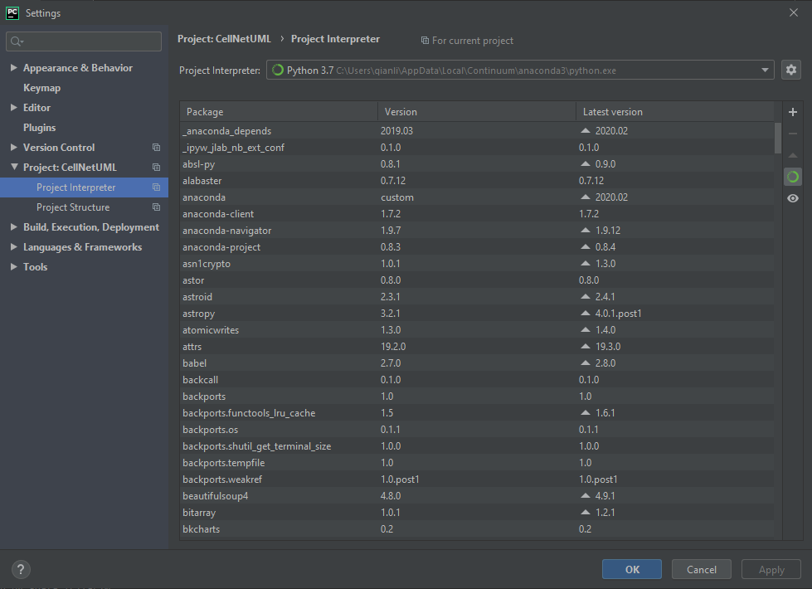

Using the + button to install all the packages you need!

One command to train our cellnet: **python main.py -data /cifar10**

100% make sure you install cuda otherwise, you will have error. cudnn is for speed up your training.

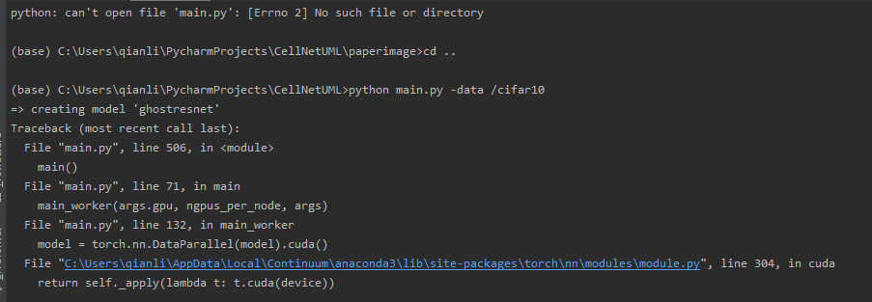

In order to train our cellnet(default='ghostresnet') we have set the default as this ghostresnet. Because in the beginning we name it ghostresnet. There are a lot of model u can have it try.

And make sure you’re your dataset looks like this:

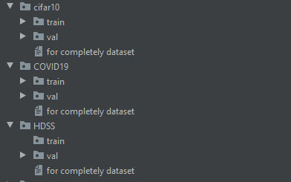

Because we used imagefolder data loader.

Therefore, your different class should be look like this:

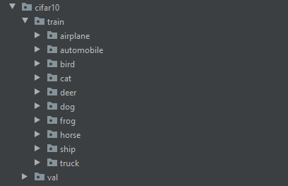

It doesn’t matter whether in each val/train folder contain img or not, the imagefolder loader by pytorch formal required this.

If you are training your dataset, you do not need to set –resume and others things and do not put your main.py in others places.

1. Your .lsf training recorder should be like this: if you are training with batch system, it will give out .lsf file. Just rename into .txt file.

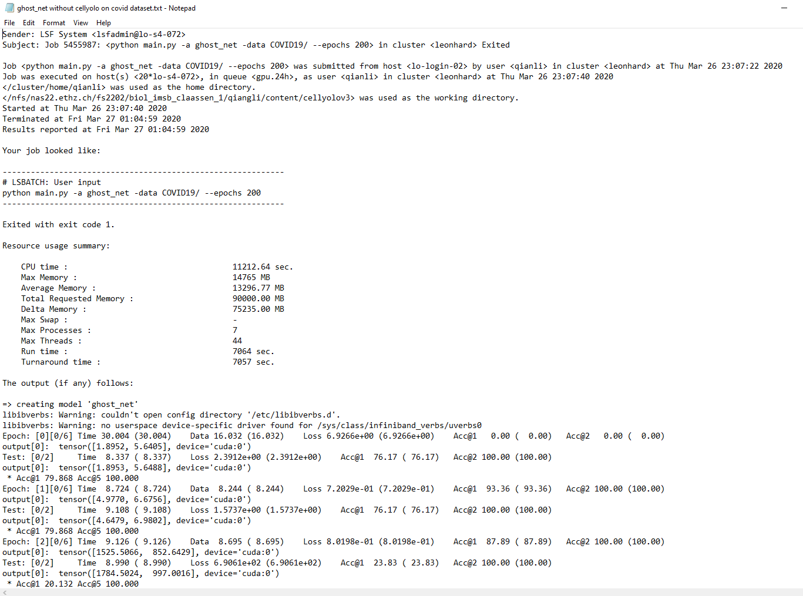

1. Then you can use our readlsf.py to filter out the TOP-1 Val Acc. Into a txt file (readlsf.py) it is very simply code. Then you can draw graph by Minitab software or any data analysis software into very nice plot.

